Media Productions
Production Schedule Call Sheet
THUMBNAILS
Film Title: “House”
Client: Lionsgate
Writer: Alyssa Rebustes
Date: 17 October 2012
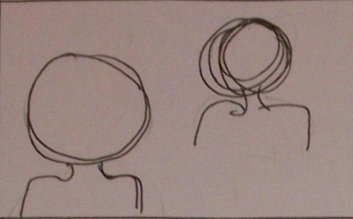
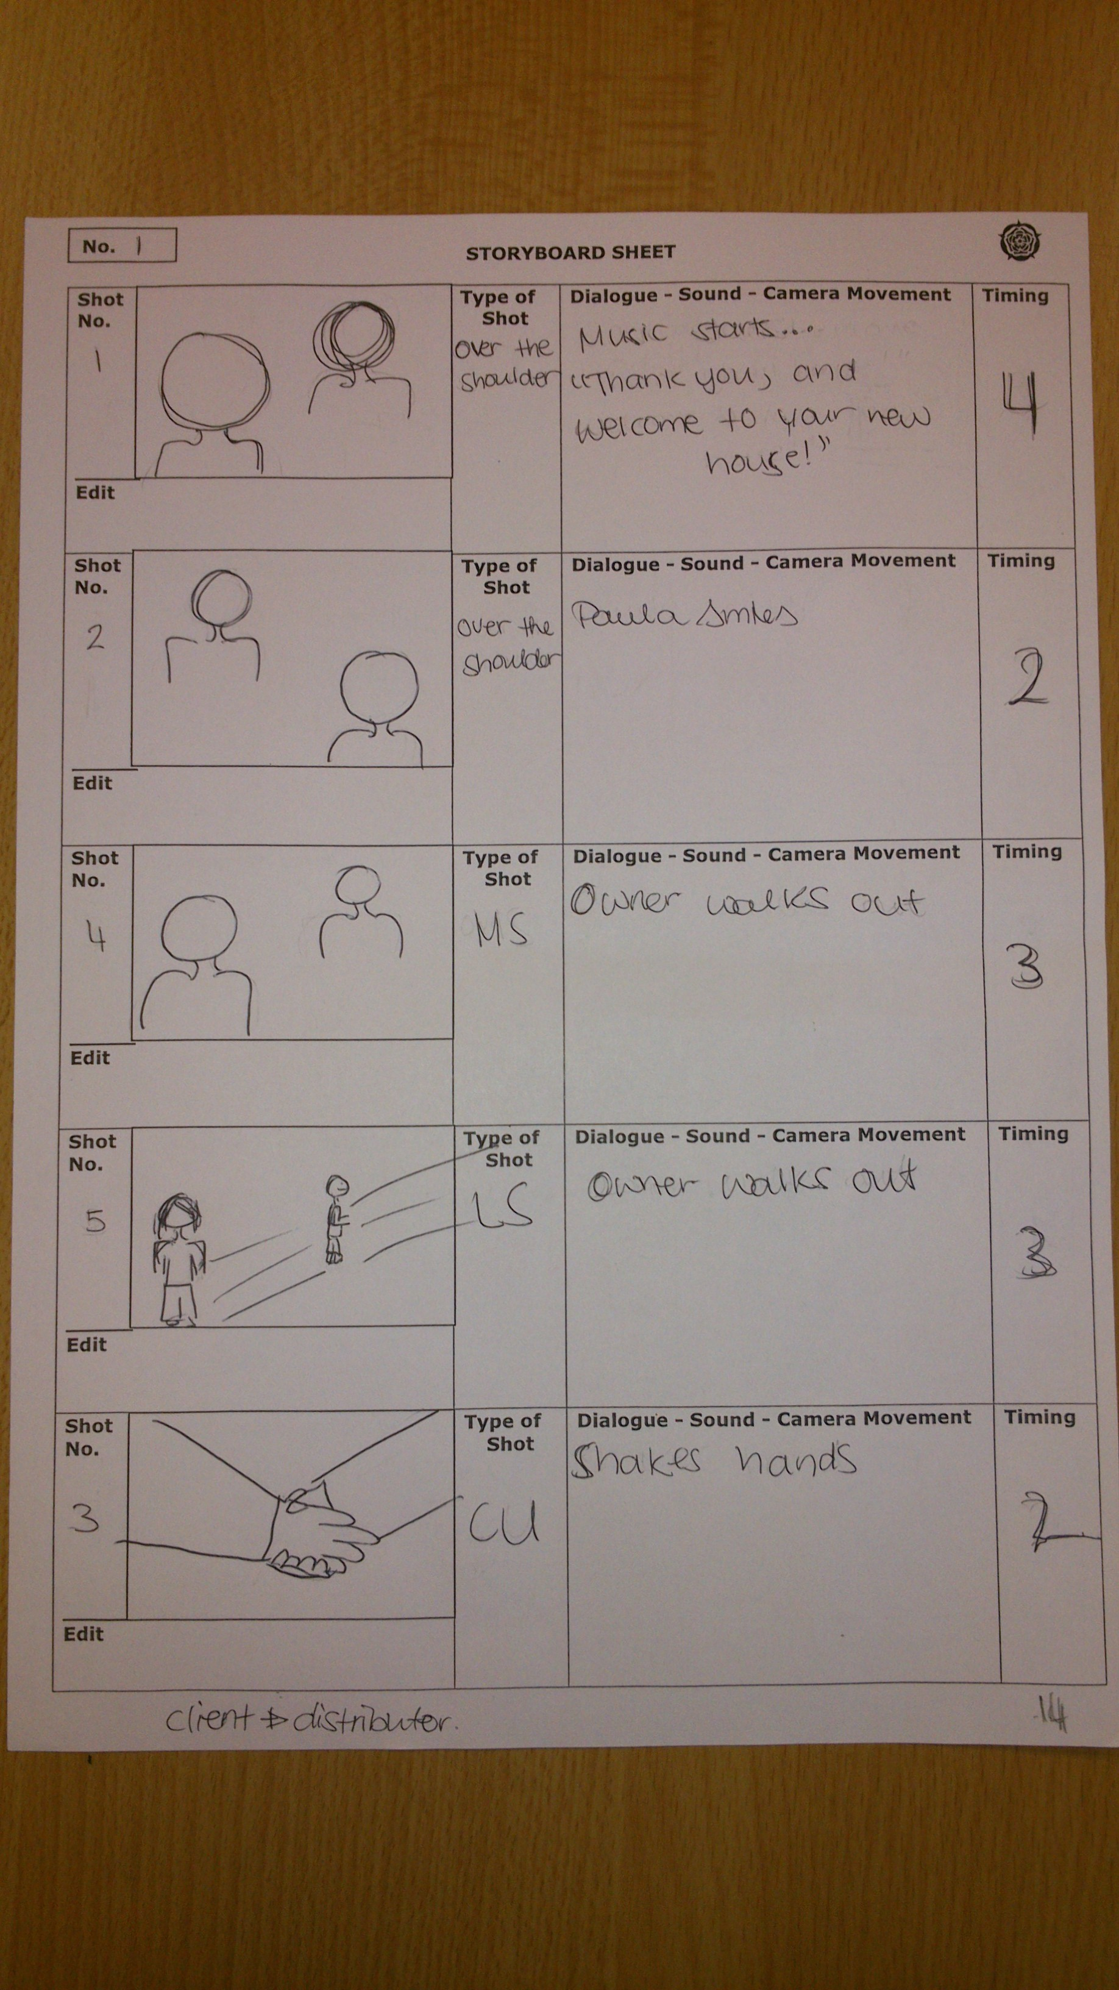
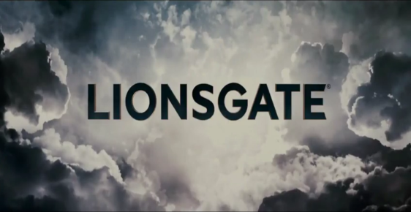
.
Paula Ponce as Hannah Queens
Paula

Paula

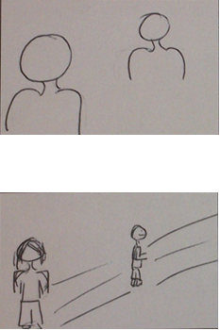
Paula
Paula

